Institute of Computer Technology

B. Tech Computer Science and Engineering

Subject: Computer Organization (2CSE205)

**PRACTICAL-9**

**AIM: - To study and design arithmetic logic unit (ALU).**

**THEORY: -**

* An arithmetic logic unit (ALU) represents the fundamental building block of the central processing unit of a computer. An ALU is a digital circuit used to perform arithmetic and logic operations.
* An arithmetic logic unit (ALU) is a digital circuit used to perform arithmetic and logic operations. It represents the fundamental building block of the central processing unit (CPU) of a computer. Modern CPUs contain very powerful and complex ALUs. In addition to ALUs, modern CPUs contain a control unit (CU).
* Most of the operations of a CPU are performed by one or more ALUs, which load data from input registers. A register is a small amount of storage available as part of a CPU. The control unit tells the ALU what operation to perform on that data and the ALU stores the result in an output register. The control unit moves the data between these registers, the ALU, and memory. A simple block diagram of a 1 bit ALU for operations and, or, xor and Add is shown here:





**Components:**

1. 4-bit Full Adder
2. AND, OR, XOR and NOT
3. 4 × 1 multiplexers

**Result: ALU Functional table.**

|  |  |  |  |  |
| --- | --- | --- | --- | --- |
| O | P | R | Cin | Operation |
| 0 | **1** | **0** | **0** | **F= A** |
| 0 | **1** | **0** | **1** | **F= A+1** |
| 0 | **0** | **0** | **0** | **F= A+B** |
| 0 | **0** | **0** | **1** | **F= A+B+1** |
| 0 | **0** | **1** | **0** | **F=A+B’** |
| 0 | **0** | **1** | **1** | **F=A+B’+1** |
| 1 | **0** | **0** | **0** | **AND** |
| 1 | **0** | **1** | **1** | **OR** |
| 1 | **1** | **1** | **0** | **COMPLEMENT-A** |
| 1 | **1** | **0** | **1** | **XOR** |

**LABWORK:**

4 bit ALU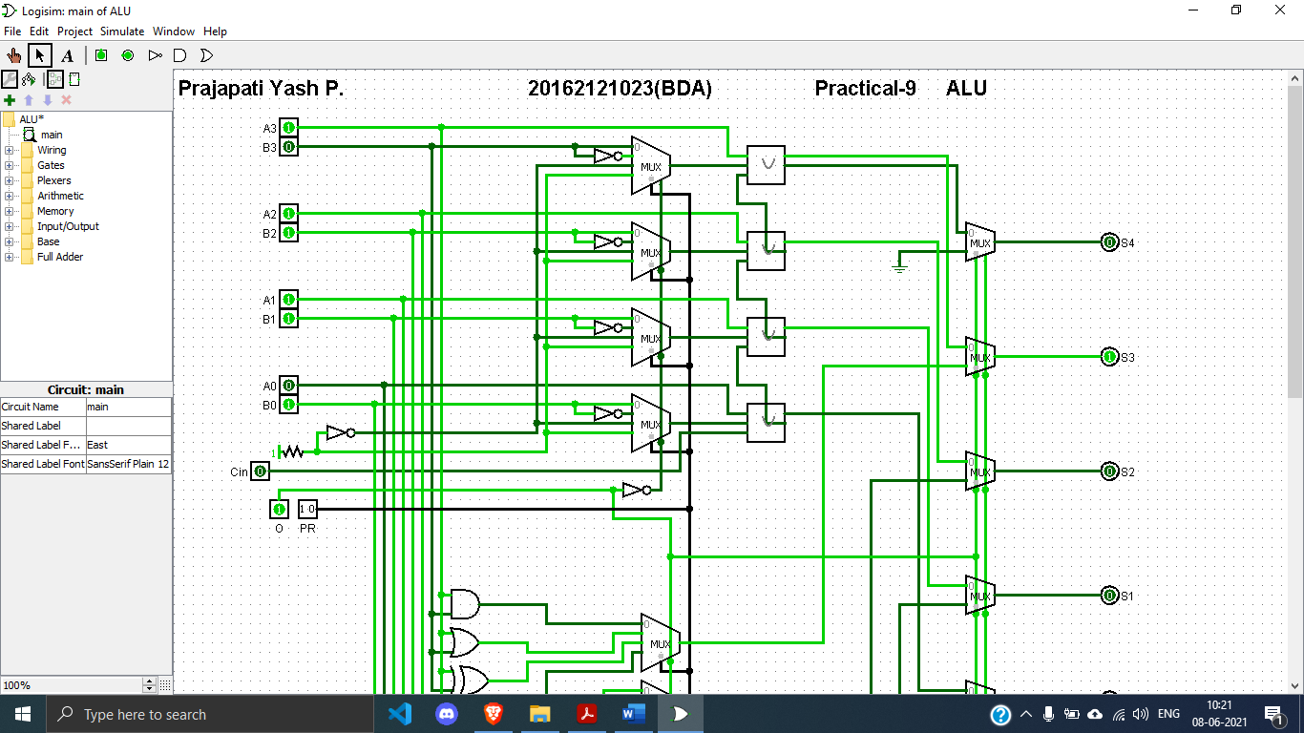

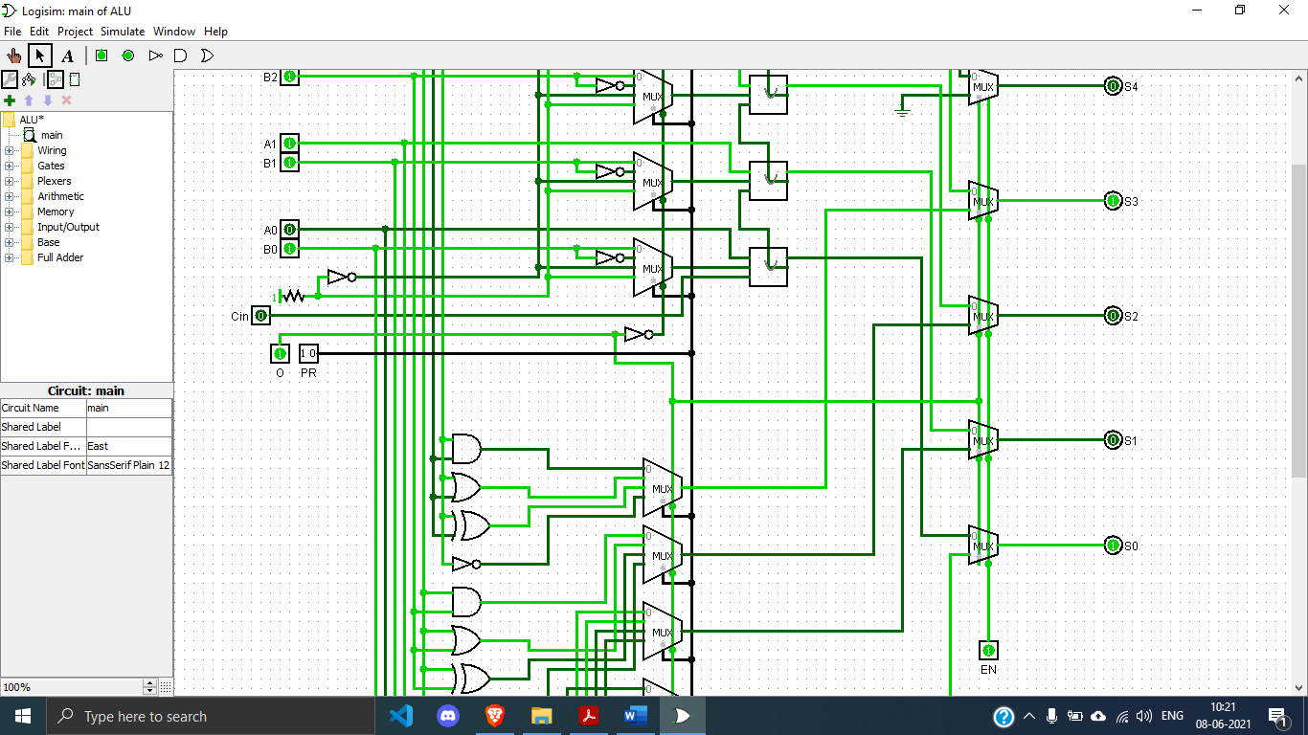

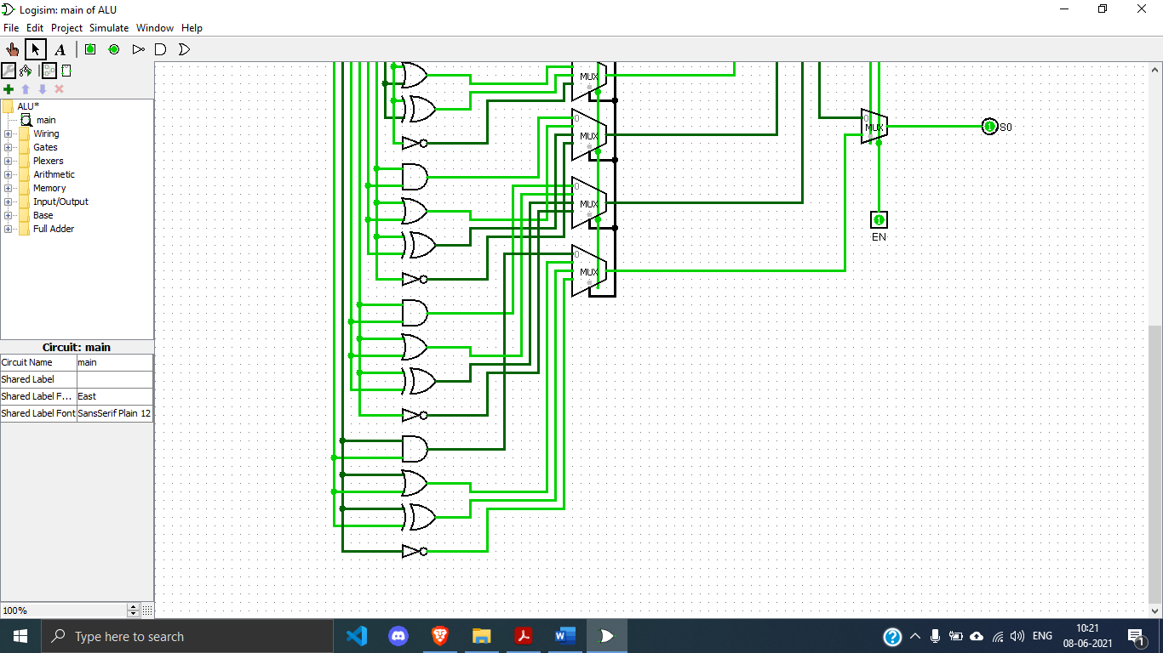

**Working:**

* **INPUT:**
  + A – 1110
  + B – 0111
* **OUTPUT:**
  + S - 1001

**Conclusion: -**

Hence, by studying the working and analysing the table we conclude the design and working of ALU.